Here is our time proven recommendation on how to best maintain your Tile, Stone, Vinyl and Wood floors

Here is our time proven recommendation on how to best maintain your tile, stone, vinyl and wood floors
Using this system you’ll never smear dirty mop water around or leave a soil attracting film behind. Grout lines will stay cleaner MUCH longer as well.
First you’ll need to pick up a gallon of a Neutral pH No Rinse Floor Cleaner such as Dynachem Neutral Cleaner. It’s a very low cost, neutral pH, and rinse free product. Used properly it will leave no residue, it will not deplete penetrating sealers used on stone and grout and for $9.95 you’ll get 128 ready to use gallons of solution!! http://www.cobbcarpet.com/zen/index.php?main_page=product_info&cPath=65&products_id=5092
Most janitorial supply shops will have their own house brand version of this product, just ask for a “Neutral pH, hard floor, rinse free” solution. Great for Granite counter tops too as it won't counteract the sealer.
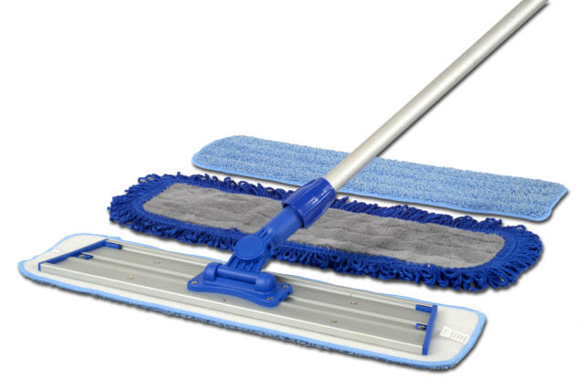Lowes and Home Depot Both sell Rubbermaid Flat Micro Fiber mops, buy one or two and some spare mop heads. I suggest you buy one mop head for every 200 feet of flooring to be cleaned. You’ll need a bucket or utility sink to dip your clean mop heads into to disperse the Neutral Cleaner. Start at the far end of the room and work your way out, Check the mop head often and when it starts to show soil, toss it into your washing machine and replace with a clean head. You should be able to clean 50 to 200 feet before needing to swap out depending on soil level.
When it comes to Mop Head selection the type with aggressive strips are best for wet cleaning, The type with a loop style fringe around the head are ideal for dust mopping before you wet clean or just for daily “sweeping” in dusty areas. The third choice you’ll find is a very soft non aggressive head that is best for applying sealers or finishes or very light wet cleaning.
You’ll be very pleased with how quick and easy it is to clean all your hard surfaces , and you’ll be amazed at how much longer your floors stay cleaned compared to any other method.

