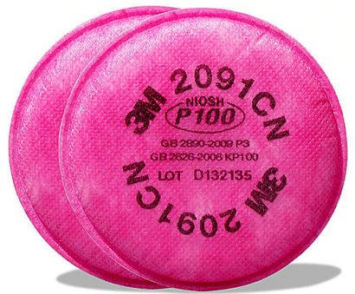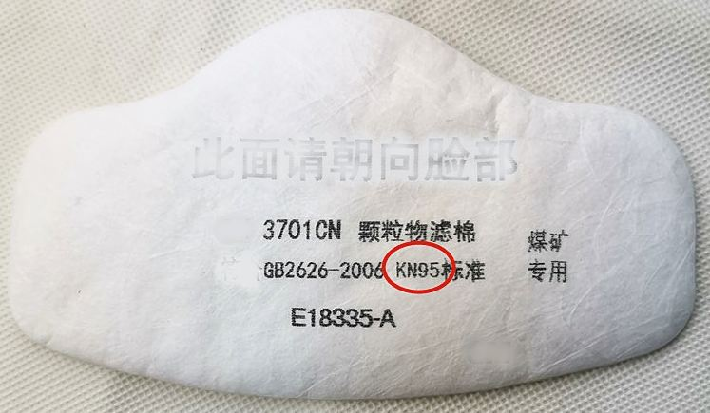
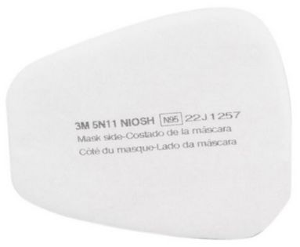 Filter Sanitizing

Sanitizing can be accomplished by several methods.
- Spray with 70% Isopropyl/Ethanol & allow to dry
- Heat is oven @160 degrees for 30 minutes
- Expose to UVC light for 10 minutes {DynaKleen}

Filter Links =N511; 2091; 3701 :

https://www.cobbcarpet.com/zen/index.php?main_page=product_info&cPath=82&products_id=5584
https://www.cobbcarpet.com/zen/index.php?main_page=product_info&cPath=82&products_id=5808
https://www.cobbcarpet.com/zen/index.php?main_page=product_info&cPath=82&products_id=5795



